Mert Aydin Animal Thing Evidence Log 13-11-2020

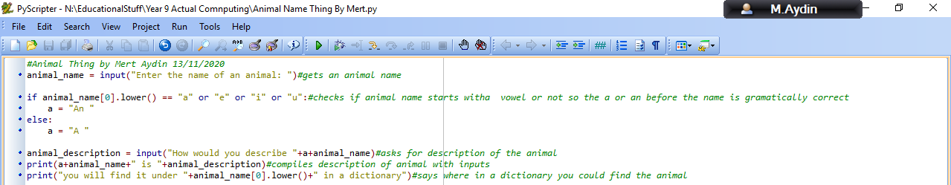Code:

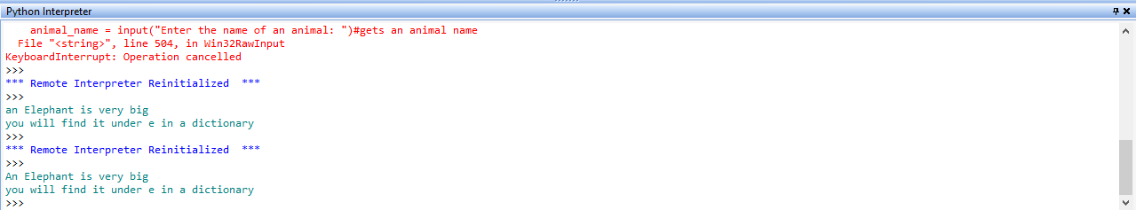Output code, only look at last output log:

#Animal Thing by Mert Aydin 13/11/2020

#gets an animal name

#checks if animal name starts with a vowel or not so the a or an before the name is gramatically correct

#asks for description of the animal

#compiles description of animal with inputs

#says where in a dictionary you could find the animal